Introduction
This document describes how to install Internet Information Services (IIS) 8.5 on Windows Server® 2012 R2. IIS is the Web server role in Windows Server 2012 R2. The Windows Server 2012 R2 operating system has all the IIS features needed to support the hosting of Web content in production environments. Windows 8 also includes IIS features, but feature availability depends on the operating system version.
Note: You can use the procedures in this document to install IIS 8.0 or IIS 8.5.
The Web server has a modular design that enables you to customize a server by adding or removing modules to meet your specific needs. The Install IIS 8.5 on Windows Server 2012 R2 section describes how to install modules, and the Modules in IIS 8.5 section below describes the functionality that each module provides and which modules are installed by default.

Before You Begin
Ensure that you have administrative user rights on the computer on which you plan to install IIS 8.5. Note that by default, you do not have administrative user rights if you are logged on as a user other than as the built-in administrator, even if you were added to the local Administrators group on the computer.
Log on either to the built-in administrator account, or explicitly invoke applications as the built-in administrator by using the runas command-line tool.
Note: You can run runas /user:administrator cmd.exe so that every application you run from that command line will be elevated, eliminating the need to use the runas syntax from that command line.
If you are logged on to an account other than the built-in local administrator account, you may see the following security alert dialog box.
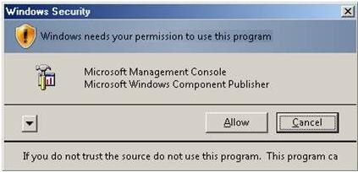

Install IIS 8.5 on Windows Server 2012 R2
IIS is one of the server roles on Windows Server 2012 R2, named Web Server (IIS). IIS can be installed through the graphical user interface (GUI) by using the new Server Manager interface after the Windows Server operating system is installed.
Server Manager provides a single dashboard to install or uninstall server roles, role services, and features. Server Manager also gives an overview of all currently installed roles and features.
When you install IIS 8.5 using the Windows Server 2012 R2 Server Manager, the steps you perform are different when you install IIS for the first time, as opposed to when you add roles, services, or features to an existing IIS installation.
For more information on how to run the installation wizards in Server Manager, see Install or Uninstall Roles, Role Services, or Features.

Install IIS 8.5 for the first time in the Server Manager
When the Web Server (UI) role is chosen for the first time in the Add Roles and Features Wizard in Server Manager, the basic components and services needed for IIS are automatically selected. The following procedure will install Internet Information Services on a running physical server when IIS has not already been installed. To change an existing installation of IIS, perform the next procedure, Install additional role services for IIS. These two procedures involve different steps.
- Open Server Manager by clicking the Server Manager icon on the desktop.
- In the Server Manager window, with the Dashboard and Quick Start selected, click Add roles and features, or click the Manage menu, and then click Add Roles and Features.
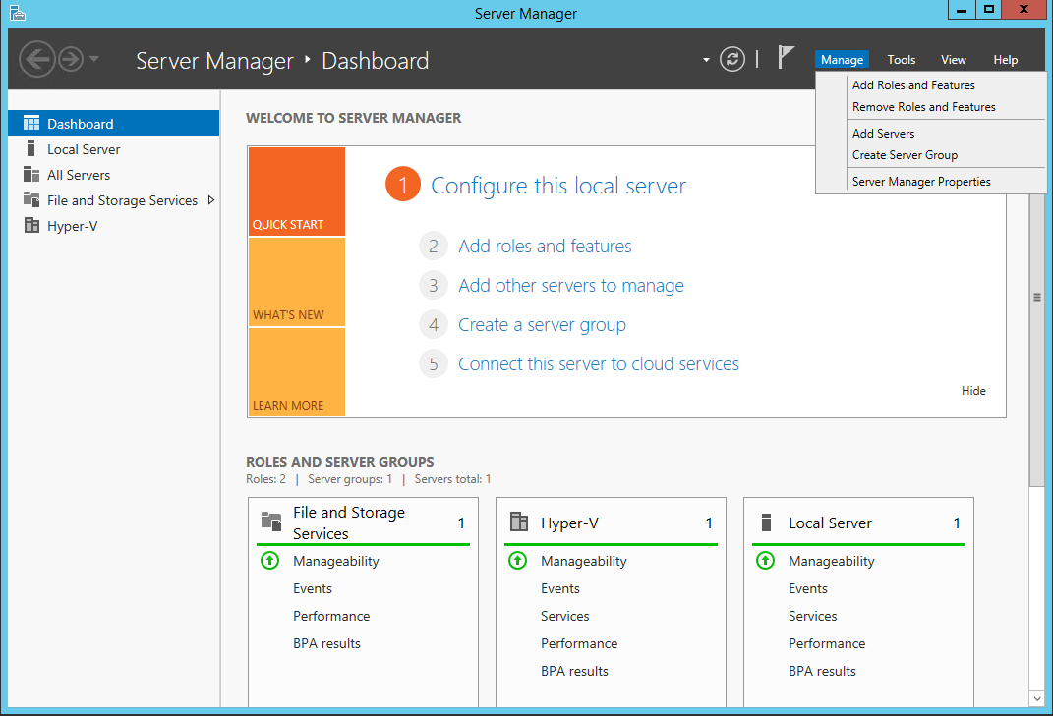
- The Add Roles and Features Wizard will start with a Before You Begin page. The wizard asks for verification of the following:
  - The administrator account has a strong password.
  - The network settings, such as IP addresses, are configured.
  - The most current security updates from Windows® Update are installed.
- On the Before You Begin page, click Next.
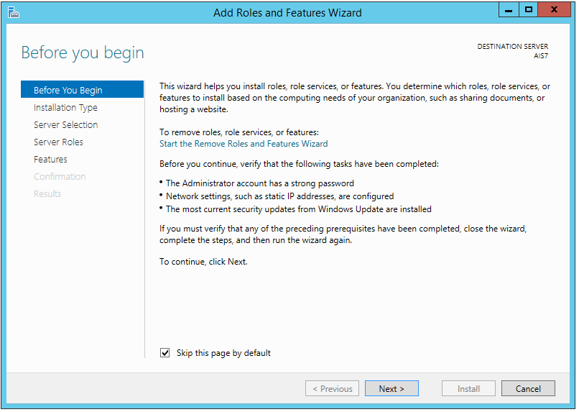
- On the Installation Type page, select Role-based or feature-based installation to configure a single server. Click Next.
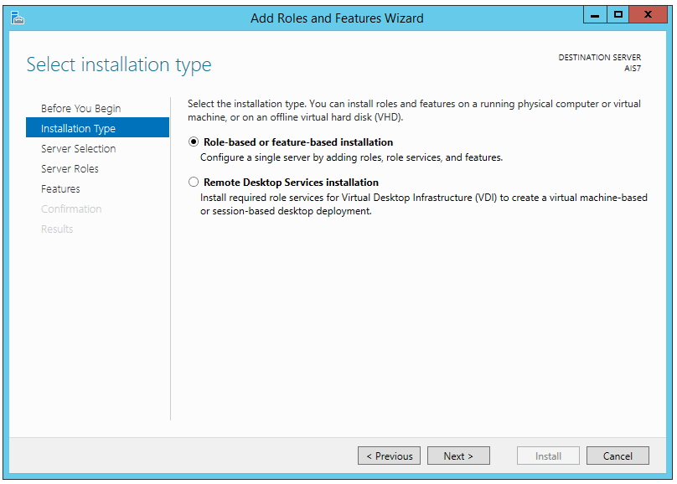
- On the Server Selection page, select Select a server from the server pool, and then select a server; or select Select a virtual hard disk server, select a server to mount the VHD on, and then select a VHD file. Click Next.
Note: To connect to the virtual hard disk, the virtual machine must be turned off and disconnected. If you select a VHD file from a network share, that share must grant Read and Write permissions to the computer (local system) account of the server that you selected to mount the VHD (user-only account access is not sufficient).
Note: Servers in a server pool will be available only if they have been added by the Add other servers to manage command in Server Manager.
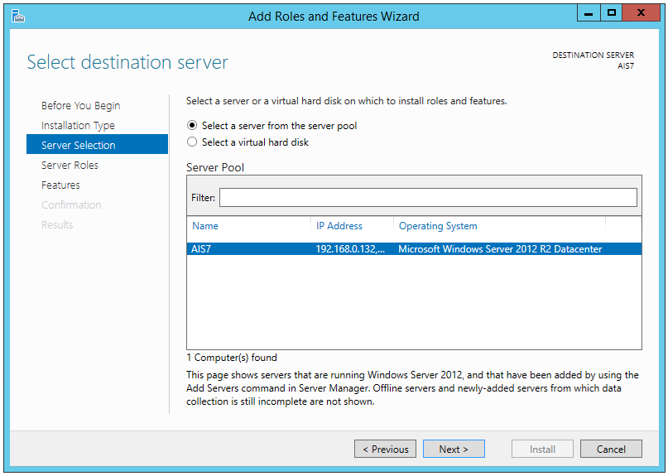
- On the Server Roles page, select the Web Server (IIS) checkbox.
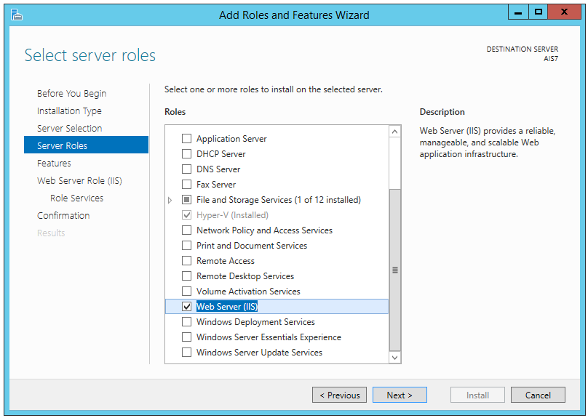
- In the Add Roles and Features wizard, click Add Features.
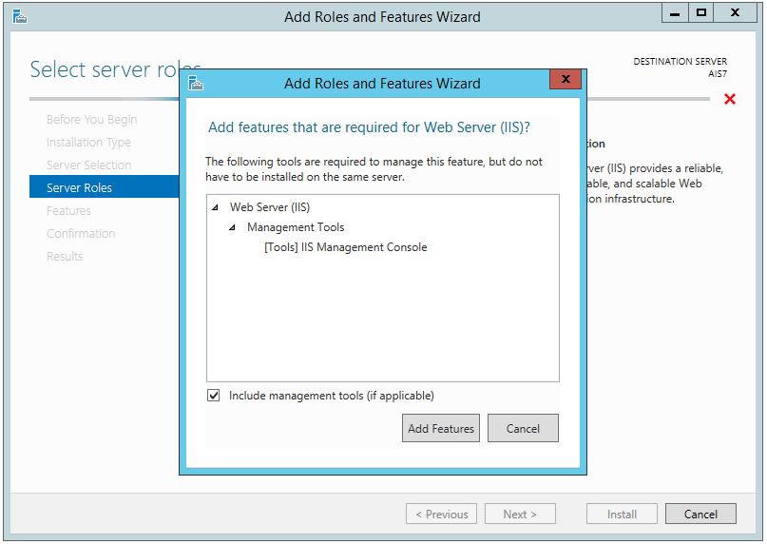
- On the Server Roles page, click Next.
Note: The features required for the default role services of Management Tools and IIS Management Console will be preselected in the Features page.
- On the Features page, select the SMTP Server checkbox.
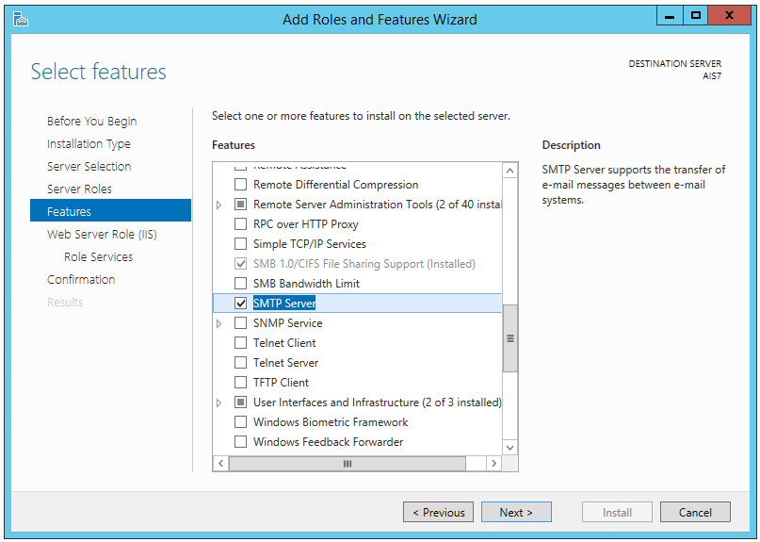
- In the Add Roles and Features wizard, click Add Features.
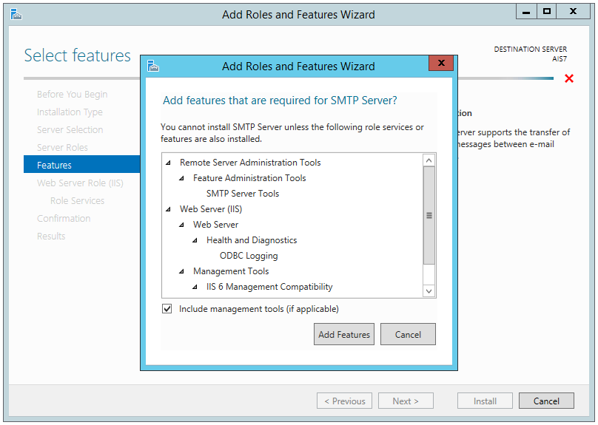
- On the Features page, click Next.
- On the Web Server Role (IIS) page, click Next.
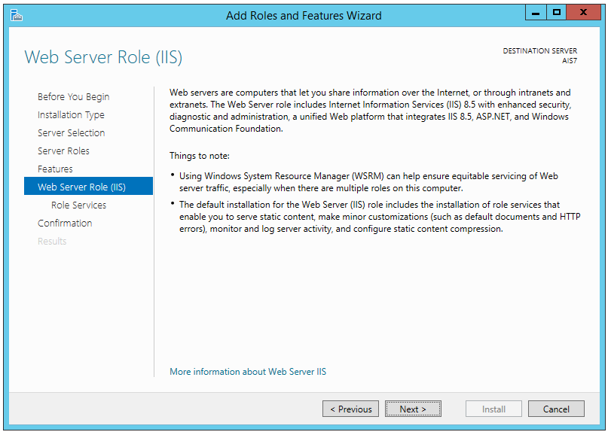
- On the Role Services page, select the Web Server -> Application Development -> ASP.NET 4.5 checkbox.
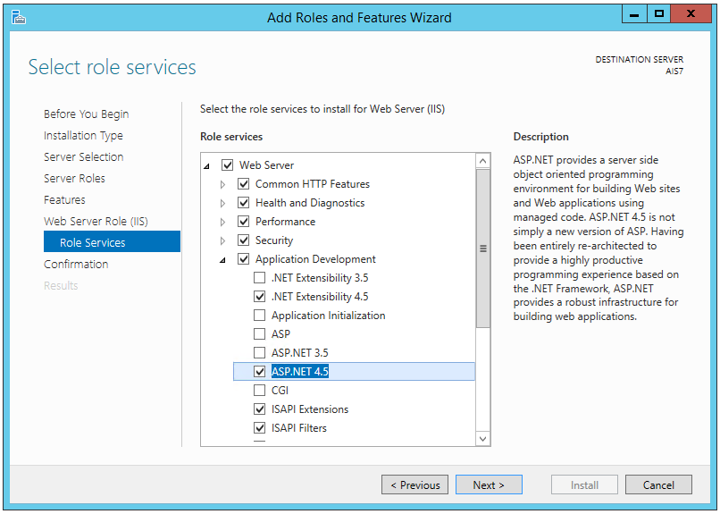
- In the Add Roles and Features wizard, click Add Features.
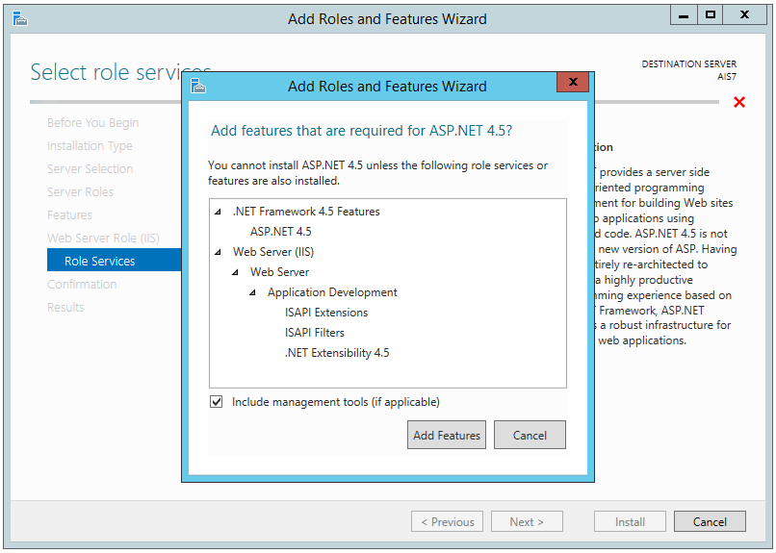
- On the Confirmation page, verify the role services and features that are selected. Select Restart the destination server automatically if required to restart the destination server if the settings need to take immediate effect.
When you are ready to start the installation process on the Confirmation page, click Install.
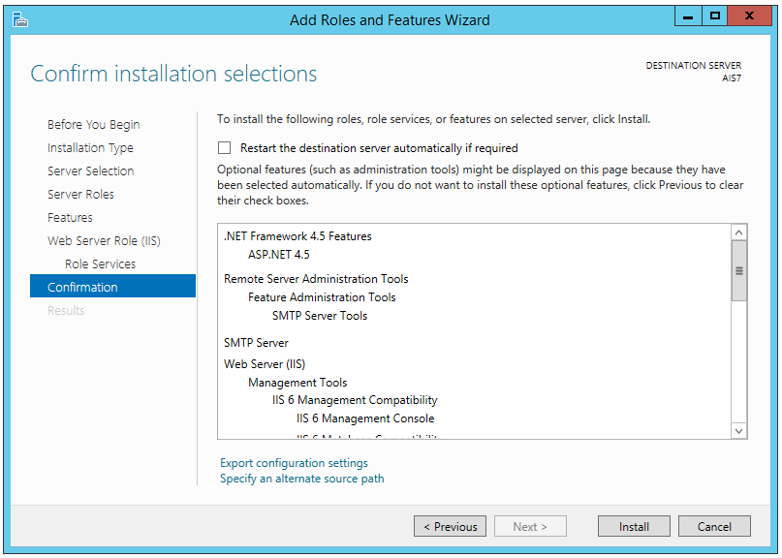
- The Installation Progress page is displayed. You can close the wizard without interrupting running tasks. You can view task progress or open the page again by clicking Notifications in the notification area, and then clicking Task Details.
- On the Results page, verify that the installation succeeds, and then click Close.
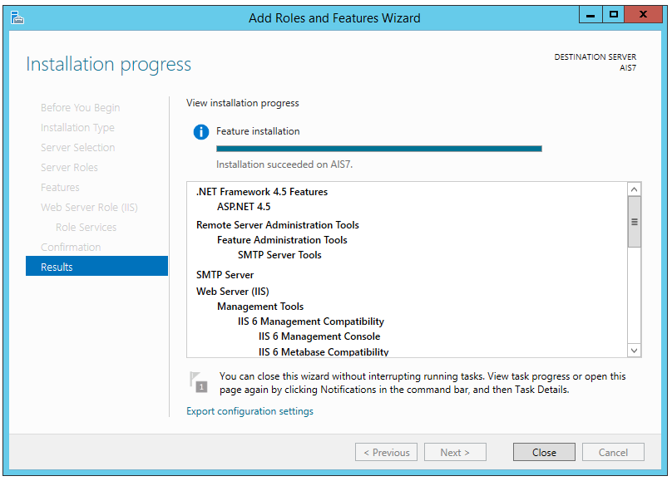
- Confirm that the Web server works by opening a Web browser, and verifying that the following default Web page is displayed when you use the http://localhost address.
